Contents
1. Introduction: 1
2. Activities Undertaken 1
2.1 Key Research & Discussion Areas: 1
2.2 Objectives: 2
2.2 Data source and description: 2
2.4 Data preprocessing and cleaning: 4
3. Contribution to the organization: 4
3.1 Trend Analysis for 2015-2022: 4
3.2 Comparative Analysis for 2015-2022: 6
3.3 Strategies for Realizing Femlink's Vision: 7
4. Reflection: 8
5. Personal Benefits: 9
6. Professional Values and Behavior: 10
References: 12

1. Introduction:
In a world where the scourge of violence against women persists, impacting the very fabric of societies globally. Fiji serves as a microcosm of the difficulties and hopes associated with addressing this serious problem. Despite concerted efforts, the statistics on violence against women in Fiji reveal a complex narrative, reflecting both progress and persisting obstacles in addressing this pressing concern.
Through an examination of the patterns and figures from the past several years—especially when comparing data from 2022 with the first few months of 2023—we can extract important information about how violence against women is changing in Fiji. This analysis not only clarifies dominant trends and processes but also acts as a compass, pointing the way towards specific policy initiatives and actions.
FemLink Pacific, an organisation committed to elevating the voices of women and marginalised groups, is at the vanguard of the Pacific region's battle for gender equality and justice. FemLink Pacific aspires to a world in which every person, regardless of gender, achieves equality and dignity through an unrelenting dedication to inclusivity and empowerment.
This report endeavors to dissect the strategies and objectives of FemLink Pacific while closely scrutinizing the data pertaining to violence against women in Fiji over the past eight years and the early months of 2023. Through this comprehensive analysis, our aim is to contribute meaningfully to the ongoing discourse and collaborative efforts aimed at forging a safer and more equitable society for all women.

2. Activities Undertaken

2.1 Key Research & Discussion Areas:
In this report, we are focusing on the following questions:
- What are the key differences and similarities in reported cases of violence against women in Fiji between 2022 and the first three quarters of 2023?
- How do these findings inform our understanding of the evolving nature of violence against women in Fiji, and what implications do they have for addressing ongoing challenges?
- Are there any notable trends or patterns in the data that warrant further investigation or targeted interventions?
- What specific strategies and collaborative actions are essential for realizing FemLink's vision of gender justice and equality in the Pacific region?
- How can stakeholders, including governments, civil society organizations, and community members, contribute to these efforts?

2.2 Objectives:
The primary objective of this report is to visualize the trends in violence against women in Fiji from 2015 to 2022, followed by a comparative analysis of FWCC data on violence and related cases between 2022 and January-August 2023. Additionally, the report aims to explore Femlink's commitment to gender justice and equality in the Pacific Region and assess the strategies and actions necessary to achieve this vision. Furthermore, the report will investigate key drivers and contributing factors to violence against women in Fiji, examining the impact of social and economic factors on the prevalence of violence. Lastly, the report will provide recommendations for government officials, stakeholders, non-governmental organizations, international organizations, and community leaders to strengthen efforts towards preventing and addressing violence against women and promoting gender equality in Fiji and the broader Pacific region.

2.2 Data source and description:
The data for violence against women in Fiji is collected from various sources and websites. Primary data is sourced from the Fiji Women's Crisis Center (FWCC) [ https://www.fijiwomen.com/publications/statistics/fiji-womens-crisis-centre-statistics/ ]. In addition to this primary data, supplementary information is obtained from the Fiji National Action Plan to Prevent Violence Against All Women and Girls 2023-2028, the National Survey Summary by FWCC, and the World Bank website for the total population of women in Fiji [ https://data.worldbank.org/indicator/SP.POP.TOTL.FE.IN?end=2022&locations=FJ&start=2015]
Qualitative data, such as case studies are also integrated to capture the lived experiences of women affected by violence and inform policy recommendations.The inclusion of data from multiple sources allows for triangulation and cross-validation, enhancing the reliability and validity of the findings presented in the report.
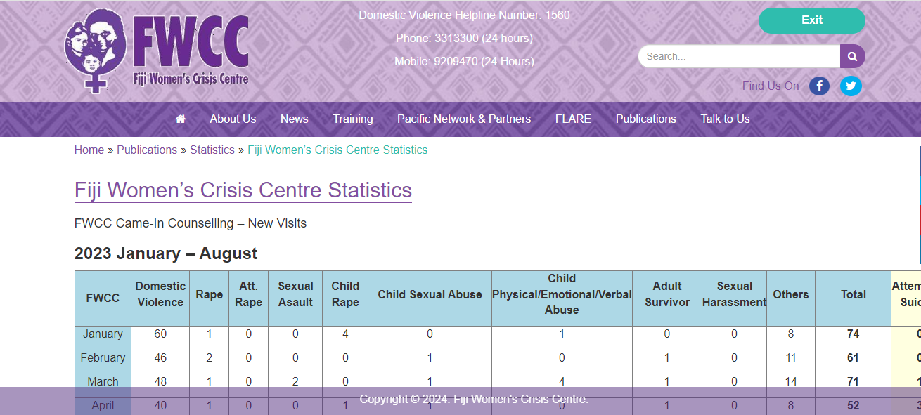
Fig 1: Fiji Women’s Crisis Center Website
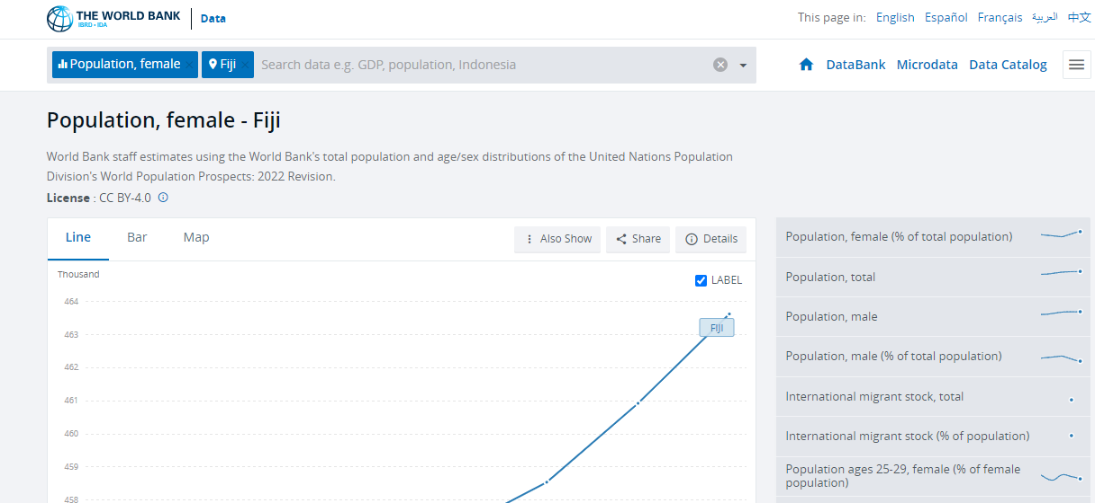
Fig 2 : The World Bank Website

2.4 Data preprocessing and cleaning:
Data collected from FWCC spans back to 1984, but for the purpose of this report, only data from the past 8 years has been selected for analysis. Additionally, certain columns such as Child Rape, Child Sexual Abuse, and Child Physical/Emotional/Verbal Abuse, which are not within the scope of this analysis, have been excluded. To provide a clearer representation of trends, a new row has been added to calculate the difference between the number of cases reported in 2022 and the first three quarters of 2023, highlighting fluctuations over time. Furthermore, a percentage difference row has been incorporated to express these fluctuations in percentage terms, offering additional insights into the data.

3. Contribution to the organization:
Based on the provided data from the Fiji Women's Crisis Center (FWCC), we can perform data analysis to gain insights into the trends and patterns of reported cases of violence against women. Here are some key points of analysis:

3.1 Trend Analysis for 2015-2022:
An analysis of reported cases of violence against women in Fiji spanning eight years reveals fluctuating trends across various categories. These trends highlight the advancements made as well as the continuous difficulties in combating gender-based violence. Line and bar graphs used as visual aids provide a clear understanding of these processes.
- Domestic Violence: There is a notable decline in reported cases of domestic violence from 2015 to 2021, with a slight increase in 2022. Overall, there seems to be a decreasing trend in domestic violence cases over the years.
- Rape: Reported cases of rape show some variability over the years, with fluctuations in the number of cases. However, there is a slight increase in 2022 compared to the previous year.
- Attempted Rape: The data indicates fluctuations in reported cases of attempted rape, with no clear trend observed over the years. The numbers remain relatively low compared to other categories.
- Other Sexual Offences: There are fluctuations in reported cases of other sexual offenses, with no consistent trend observed. The numbers remain relatively low compared to other categories.
- Adult Survivor: Reported cases of adult survivors of violence show some variability over the years, with a decrease observed from 2015 to 2020 followed by an increase in 2021 and a slight decrease in 2022.
- Sexual Harassment: The data indicates fluctuations in reported cases of sexual harassment, with a decrease observed from 2015 to 2019 followed by an increase in 2020 and a subsequent decrease in 2021 and 2022.

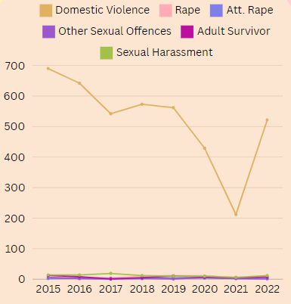
Fig 1: Line Graph
A line graph is employed to visualize trends in different types of violence against women. It is evident that domestic violence consistently stands out as the most prevalent form of violence. From 2019 to 2021, there was a notable decrease in reported cases of domestic violence. However, in 2022, there was a significant increase in reported cases, indicating a reversal of the previous trend
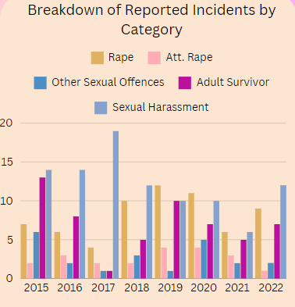
Fig 2:Bar Graph representing the breakdown by category
A bar graph is utilized to visualize the variation in reported cases across different categories, excluding domestic violence. In these categories, significant fluctuations are observed over the years. Specifically, there is a noticeable increase in reported cases of rape and sexual harassment from 2015 to 2022

3.2 Comparative Analysis for 2015-2022:

Comparing the data for the year 2022 with the overall population of women in Fiji provides insight into the prevalence of violence against women. Analysis reveals that approximately 1 in every 47 women experiences sexual harassment, while approximately 1 in 70 women faces issues related to rape, and approximately 1 in 100 women experiences domestic violence. These three forms of violence are notably the most common based on the overall comparison.
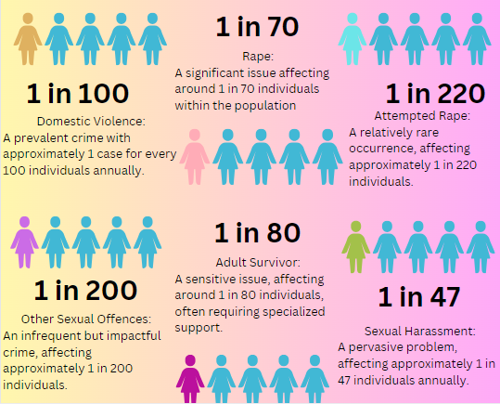
Fig 3: Comparison of 2022 data with overall population
In comparing 2022 to the first three quarters of 2023, there was a 33.33% increase in other sexual offenses and a 14.29% increase in rape cases, while there was no change in attempted rape. However, domestic violence decreased by 19.72%, and there was a steady decrease in sexual harassment by 84.62%.
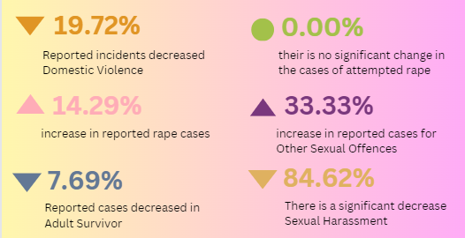
Fig 4: represents comparison of 2022-(Jan-Aug) 2023
Apart from these patterns, it is significant that attempts at rape continued to be stable, suggesting continuous reporting or efforts at prevention. Concerns regarding the efficacy of present intervention techniques are raised by the notable rise in rape cases and other sexual offences. Moreover, the significant decline in instances of domestic violence points to the possibility of success for awareness-raising initiatives or assistance programmes. These results highlight how crucial it is to monitor abuse against women continuously and implement focused treatments.

3.3 Strategies for Realizing Femlink's Vision:
The goals and vision of Femlink pacific for change through the use of fessible media and information, communication and technology where there is gender justice, ecological sustainability, peace, freedom , equality and human rights..Multiple strategies are proposed to achieve these objectives, and this report outlines a selection of key strategies aimed at realizing Femlink's vision.
It is essential to adopt a diverse approach that tackles several aspects of societal transformation in order to realize Femlink Pacific's vision. This research examines the application of creative communication tactics, community involvement programs, and advocacy campaigns to promote human rights and gender equality in the Pacific area. Femlink seeks to promote sustainable progress towards a more equitable and inclusive society by empowering local communities and collaborating with a wide range of partners.
Achieving the vision outlined by Femlink involves several strategies and actions:
- Policy advocacy: strategically influences decision-makers to enact or change policies, utilizing research, lobbying, and public campaigns to drive legislative reforms and address pressing issues effectively.
- Capacity Building: This may involve providing skills training, leadership development, and education on legal rights and resources available for survivors of violence.
- Advocate and raise awareness: Promote gender justice, ecological sustainability, and human rights through campaigns and community outreach in the Pacific.
- Community building: entails fostering inclusive dialogue and collaboration among diverse members through events and initiatives, promoting solidarity and collective action towards shared goals, thereby enhancing social cohesion and resilience.
- Build partnerships: Collaborate with stakeholders to leverage resources and coordinate efforts against violence and for gender justice.
- Engage communities: Provide support services and grassroots initiatives to address the unique needs of women and girls.
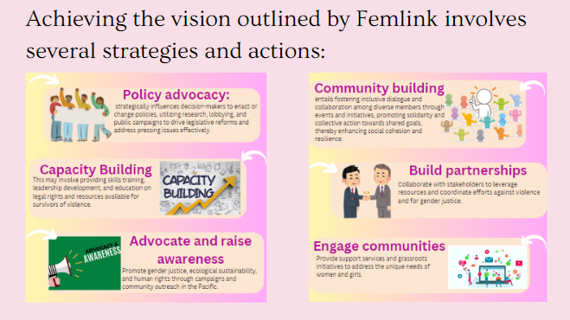
Fig 5: Represents strategies and actions

4. Reflection:

After completing my internship with Think Pacific and participating in action projects on violence against women with FemLink Pacific, I reflected on the challenges and successes of the experience. I gained a deeper understanding of the complexities of addressing gender-based violence and recognized the importance of empathy and cultural sensitivity in this work. Additionally, I realized the significance of intersectionality in understanding the various factors that contribute to violence against women, including socio-economic status, ethnicity, and access to resources.
Emotionally, I was both challenged by the seriousness of the problems we were facing and emboldened by the chance to help bring about constructive change. Observing the tenacity of survivors and the commitment of grassroots activists motivated me to carry on for social justice and gender parity. But I also occasionally struggled with feelings of powerlessness and frustration as I tried to overcome the structural obstacles that support violence against women.
Moving forward, I am committed to continuing my advocacy for gender equality and social justice, both within my professional endeavors and personal actions. I recognize the importance of ongoing education and self-reflection to deepen my understanding of gender-based violence and contribute effectively to efforts to eradicate it. Furthermore, I am dedicated to amplifying the voices of survivors and marginalized communities, ensuring that their experiences are at the forefront of our advocacy efforts."

5. Personal Benefits:

My internship with Think Pacific and participation in action projects with FemLink Pacific provided numerous personal benefits. I developed valuable skills in research, communication, and teamwork, which I can apply in future professional roles.Working on the topic of violence against women offers opportunities for both personal and professional growth, empowering to contribute meaningfully to creating a more just and equitable society. Below are a few of the benefits:

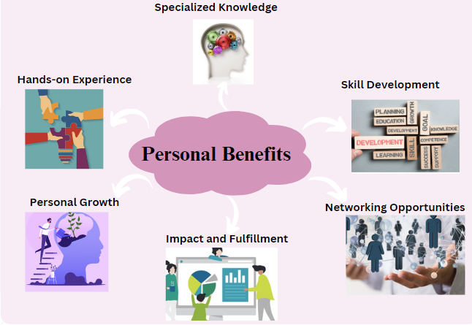
Fig:6 Personal benefits

1. Hands-on Experience: Working as an intern with Think Pacific and FemLink Pacific provided invaluable practical experience in tackling challenging social issues, including violence against women. I had the opportunity to work closely with mentors, engage in actual projects, and contribute to meaningful efforts to combat gender-based violence.
2. Specialized Knowledge: Interning on violence against women within the Pacific context allowed me to develop specialized knowledge in this field. I gained insights into the unique challenges and dynamics faced by women in the Pacific region, enhancing my understanding of gender-based violence and its intersection with society, culture, and the law.
3. Skill Development: Interning with Think Pacific and FemLink Pacific offered opportunities to develop a diverse range of skills, including research, communication, networking, project management, and cultural competency. These skills are highly transferable and can be applied to various future roles and endeavors.
4. Networking Opportunities: Engaging with professionals, experts, and community members throughout the internship provided valuable networking opportunities. Building connections within the Think Pacific and FemLink Pacific organizations opened doors to future collaborations, mentorship, and career opportunities.
5. Personal Growth: Working on such a critical and sensitive issue as violence against women fostered personal growth and resilience. It required empathy, critical thinking, and a commitment to social justice, leading to greater self-awareness, empathy, and a sense of purpose.
6. Impact and Fulfillment: Contributing to the mission of Think Pacific and FemLink Pacific in addressing violence against women has been deeply fulfilling. Knowing that my work has the potential to make a positive impact on the lives of women and communities in the Pacific region has brought a sense of fulfillment and purpose to my internship experience.

6. Professional Values and Behavior:

Interning with Think Pacific and participating in action projects on violence against women with FemLink Pacific instilled crucial professional values and behaviors essential for addressing complex social issues effectively. Through these experiences, I learned the importance of empathy, integrity, and social responsibility when working with communities affected by violence against women. Moreover, I gained a deeper appreciation for the significance of active listening and empathy in building trust and fostering meaningful connections with survivors and community members. I have learned to approach sensitive topics with sensitivity and respect, demonstrating a commitment to ethical conduct and the well-being of survivors and communities affected by gender-based violence.
My involvement in community-based initiatives underscored the importance of grassroots empowerment and community-led solutions in driving sustainable change. I witnessed firsthand the transformative power of collective action and community mobilization in addressing systemic issues and promoting social justice.
Furthermore, my experiences have honed my problem-solving skills and ability to think critically about complex social issues. I have gained practical experience in project management, data analysis, and advocacy, equipping me with valuable skills applicable in various professional settings. Additionally, my internship has provided opportunities for personal growth, challenging me to step outside my comfort zone, build resilience, and develop a deeper understanding of social justice issues.
Moving forward, I am committed to upholding these values and behaviors in my future career endeavors, striving to make a positive impact in society. I recognize the ongoing journey of growth and learning inherent in this work, and I am dedicated to continuous self-improvement and reflection. By championing empathy, integrity, and social responsibility in all aspects of my professional life, I aim to contribute meaningfully to building a more just and equitable world for all.

References:

- National Survey Summary pdf- https://media2-production.mightynetworks.com/asset/3f3d9a3c-14c1-4405-a9a8-bcf1adc77b6e/National-Survey-Summary.pdf?_gl=1*1ihvn9y*_ga*ODgwODYyNjExLjE3MDYyOTE2NDM.*_ga_T49FMYQ9FZ*MTcwODk3OTUzMy45LjEuMTcwODk3OTU1Mi4wLjAuMA..*_ga_NEGJ2SXNP7*MTcwODk3OTUzMy45LjEuMTcwODk3OTU1MS40Mi4wLjA.
- Fiji Women’s Crisis Center - https://www.fijiwomen.com/publications/statistics/fiji-womens-crisis-centre-statistics/
- Fiji National Action Plan to Prevent Violence Against All Women and Girls 2023-2028- https://asiapacific.unwomen.org/sites/default/files/2023-09/fiji_nap_2023-2028-digital-final.pdf
- The World Bank - https://data.worldbank.org/indicator/SP.POP.TOTL.FE.IN?end=2022&locations=FJ&start=2015
- Newland, L., 2016. Villages, violence and atonement in Fiji. Gender Violence, p.47.
- Aucoin, P.M., 1990. Domestic violence and social relations of conflict in Fiji. Pacific Studies, 13, pp.20-20.
- Tuiketei, T. and Rokoduru, A., 2010. Violence Against Women: A Public Health Perspective Project Report: Fiji 2010.

